Workflow Diagram
Train Dataset
Trained Machine Learning Model
Test Datset
Row Dataset
Accuracy of the Model
Deployment
Data Preprocessing
Data Transformation
Exploring
Split the Dataset
Heart Disease Dataset Attribute Description

S. No. | Attribute | Description | Value | Data type
1 | age | The person’s age in years | Continuous value | Numeric
2 | sex | The person’s sex | 1: male;  0: female | Binary
3 | cp | Chest pain type | -Value 0: asymptomatic  -Value 1: atypical angina  -Value 2: non-anginal pain  -Value 3: typical angina | Nominal
4 | trestbps | resting blood pressure  mm mg | Normal: Blood pressure below 120/80 mm Hg is considered to be normal | Numeric
5 | chol | cholesterol measurement in mg/dl | Continuous value | Numeric
6 | fbs | fasting blood sugar | > 120 mg/dl, 1=True;0=false | Binary
7 | restecg | resting electrocardiographic results | -Value 0: showing probable or definite left ventricular hypertrophy by Estes’ criteria  -Value 1: normal  -Value 2: having ST-T wave abnormality (T wave inversions and/or ST elevation or depression of > 0.05 mV) | Nominal
8 | thalach | maximum heart rate achieved | 71–202 | Numeric
9 | exang | Exercise induced angina | 1=Yes,  0=No | Binary
10 | oldpeak | ST depression induced by exercise relative to rest | depression | Numeric
11 | slope | the slope of the peak exercise ST segment | 0: downsloping;  1: flat;  2: upsloping | Nominal
12 | ca | The number of major vessels | 0-3 | Binary
13 | thal | A blood disorder called thalassemia | 0:NULL,  1: fixed defect(no blood flow in some part of the heart) | Binary

Angina (Chest Pain)

Angina is chest pain or discomfort caused when your heart muscle doesn't get enough oxygen-rich blood. It may feel like pressure or squeezing in your chest. The discomfort also can occur in your shoulders, arms, neck, jaw, or back. Angina pain may even feel like indigestion.
But, angina is not a disease. It is a symptom of an underlying heart problem, usually coronary heart disease (CHD).
This usually happens because one or more of the coronary arteries is narrowed or blocked, also called ischemia.
Angina can also be a symptom of coronary microvascular disease (MVD). This is heart disease that affects the heart’s smallest coronary arteries and is more likely to affect women than men.
Depending on the type of angina you have, there are many factors that can trigger angina pain. The symptoms also vary based on the type of angina you have.

Typical angina (TA) is defined as substernal chest pain precipitated by physical exertion or emotional stress and relieved with rest or nitroglycerin. Women and elderly patients are usually have atypical symptoms both at rest and during stress, often in the setting of nonobstructive coronary artery disease (CAD).

Typical Angina :-
Angina pectoris or typical angina is the discomfort that is noted when the heart does not get enough blood or oxygen. Typically, this is caused by blockage or plaque buildup in the coronary arteries. If one or more of the coronary arteries is partially or completely clogged, the heart will not get enough oxygen.
Usually, angina is a symptom that may feel like a tightness or heaviness in the central chest. It may be associated with shortness of breath and perspiration. The location of the discomfort will vary from person to person. Some people may have it in the central part of the chest, some may have it on the left side, some may have it on the right side, and some may have it radiating across the chest. It may also feel like the discomfort moves or radiates to the shoulder, arms, jaw, neck, and back. It usually does not radiate past the wrist into the hand.
Angina may occur during activities such as climbing stairs, carrying groceries, or becoming upset, angry, or going outside into the cold air. Exercise and sexual activity may also cause the symptom to occur.
Atypical Angina :-
Women may have more of a subtle presentation called atypical angina. For example, in one study of over 500 women who suffered a heart attack, 71% had fatigue, 48% had sleep disturbances, 42% had shortness of breath, and 30% had chest discomfort in the month prior to the heart attack. At the time of their heart attack, 58% had shortness of breath, 55% had weakness, 43% had fatigue, and 43% had chest discomfort. The problem may present like an indigestion feeling and can even mimic a problem related to peptic ulcer disease or gallbladder disease.
Angina may also be quite localized, and the symptoms may be mistaken for a muscular pain or muscle pull. One of my patients presented with elbow pain as his sign of a heart attack; another patient had heart attack pain that felt like she had progressively tightening handcuffs on her wrists.

Typical (classic) angina chest pain consists of
(1) Substernal chest pain or discomfort that is
(2) Provoked by exertion or emotional stress and
(3) relieved by rest or nitroglycerine (or both).
Atypical (probable) angina chest pain applies when 2 out of 3 criteria of classic angina are present.
Non-specific chest pain: If ≤ 1 of the criteria of classic angina is present, symptoms are classified as non-specific.
Typical chest pain is also called definite angina, classic angina, or typical angina.
Atypical chest pain is also called atypical/probable angina.
Non-specific chest pain is also called non-ischemic chest discomfort.

Cholesterol :-
Cholesterol is a waxy type of fat, or lipid, which moves throughout your body in your blood. Lipids are substances that do not dissolve in water, so they do not come apart in blood. Your body makes cholesterol, but you can also get it from foods. Cholesterol is only found in foods that come from animals.
Your body needs cholesterol to build healthy cells, but high levels of cholesterol can increase your risk of heart disease.
With high cholesterol, you can develop fatty deposits in your blood vessels. Eventually, these deposits grow, making it difficult for enough blood to flow through your arteries. Sometimes, those deposits can break suddenly and form a clot that causes a heart attack or stroke.High cholesterol can be inherited, but it's often the result of unhealthy lifestyle choices, which make it preventable and treatable. A healthy diet, regular exercise and sometimes medication can help reduce high cholesterol.
High cholesterol has no symptoms. A blood test is the only way to detect if you have it.
The best way to measure cholesterol is with a blood test called a lipid panel or lipid profile. You will need to fast (not eat) for 9 to 12 hours before your lipid panel.

Cholesterol is carried through your blood, attached to proteins. This combination of proteins and cholesterol is called a lipoprotein. There are different types of cholesterol, based on what the lipoprotein carries. They are:
- Low-density lipoprotein (LDL). , the "bad" cholesterol, transports cholesterol particles throughout your body. cholesterol builds up in the walls of your arteries, making them hard and narrow.
- High-density lipoprotein (HDL). , the "good" cholesterol, picks up excess cholesterol and takes it back to your liver.
A lipid profile also typically measures triglycerides, a type of fat in the blood. Having a high triglyceride level also can increase your risk of heart disease.

Risk factors
Factors that can increase your risk of unhealthy cholesterol levels include:
- Poor diet. Eating too much saturated fat or trans fats can result in unhealthy cholesterol levels. Saturated fats are found in fatty cuts of meat and full-fat dairy products. Trans fats are often found in packaged snacks or desserts.
- Obesity. Having a body mass index (BMI) of 30 or greater puts you at risk of high cholesterol.
- Lack of exercise. Exercise helps boost your body's , the "good," cholesterol.
- Smoking. Cigarette smoking may lower your level of , the "good," cholesterol.
- Alcohol. Drinking too much alcohol can increase your total cholesterol level.
- Age. Even young children can have unhealthy cholesterol, but it's much more common in people over 40. As you age, your liver becomes less able to remove cholesterol.

Complications
High cholesterol can cause a dangerous accumulation of cholesterol and other deposits on the walls of your arteries (atherosclerosis). These deposits (plaques) can reduce blood flow through your arteries, which can cause complications, such as:
- Chest pain. If the arteries that supply your heart with blood (coronary arteries) are affected, you might have chest pain (angina) and other symptoms of coronary artery disease.
- Heart attack. If plaques tear or rupture, a blood clot can form at the plaque-rupture site — blocking the flow of blood or breaking free and plugging an artery downstream. If blood flow to part of your heart stops, you'll have a heart attack.
- Stroke. Similar to a heart attack, a stroke occurs when a blood clot blocks blood flow to part of your brain.

Prevention
The same heart-healthy lifestyle changes that can lower your cholesterol can help prevent you from having high cholesterol in the first place. To help prevent high cholesterol, you can:
- Eat a low-salt diet that emphasizes fruits, vegetables and whole grains
- Limit the amount of animal fats and use good fats in moderation
- Lose extra pounds and maintain a healthy weight
- Quit smoking
- Exercise on most days of the week for at least 30 minutes
- Drink alcohol in moderation, if at all
- Manage stress

Fasting Blood Sugar Test :-
This measures your blood sugar after an overnight fast (not eating). A fasting blood sugar level of 99 mg/dL or lower is normal, 100 to 125 mg/dL indicates you have prediabetes, and 126 mg/dL or higher indicates you have diabetes.

Trestbps :- (Resting blood pressure)
High blood pressure can damage your arteries by making them less elastic, which decreases the flow of blood and oxygen to your heart and leads to heart disease.
Normal: Blood pressure below 120/80 mm Hg is considered to be normal.

What Systolic, Diastolic Blood Pressure Numbers Mean
When you get your blood pressure numbers,there are two of them. The first, or “top” one, is your systolic blood pressure. The second, or “bottom,” one is diastolic blood pressure.
Knowing both is important and could save your life.

What Does the Systolic Blood Pressure Number Mean?
When your heart beats, it squeezes and pushes blood through your arteries to the rest of your body. This force creates pressure on those blood vessels, and that's your systolic blood pressure.
Here’s how to understand your systolic blood pressure number:
- Normal: Below 120
- Elevated: 120-129
- Stage 1 high blood pressure (also called hypertension): 130-139
- Stage 2 hypertension: 140 or more
- Hypertensive crisis: 180 or more. Call 911.

What Does the Diastolic Blood Pressure Number Mean?
The diastolic reading, or the bottom number, is the pressure in the arteries when the heart rests between beats. This is the time when the heart fills with blood and gets oxygen.
This is what your diastolic blood pressure number means:
- Normal: Lower than 80
- Stage 1 hypertension: 80-89
- Stage 2 hypertension: 90 or more
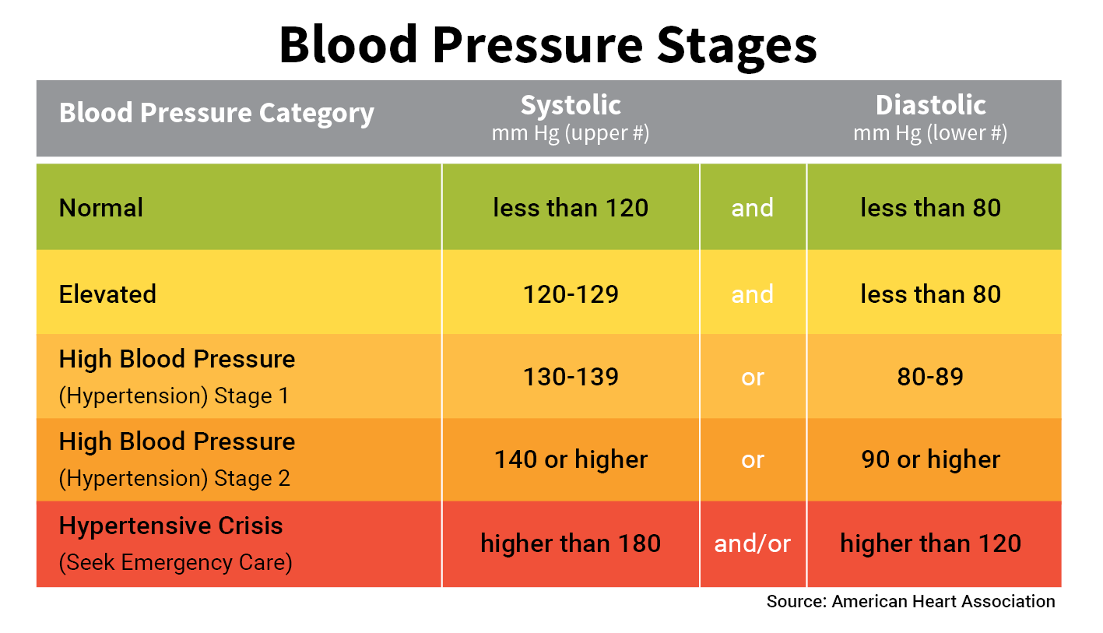
- Hypertensive crisis: 120 or more. Call 911.

restecg :- (p-atrium(above part of heart) , QRS-Ventricle(below part of heart) , T(shows normal condition after contraction)) (PR interval – changement of PR interval called arrhythmia. It signs to represent heart beat high or low )
The resting electrocardiogram is a test that measures the electrical activity of the heart.
The heart is a muscular organ which pumps blood through rhythmic contractions induced by electric impulses generated by the sinus node, the heart’s natural pacemaker.
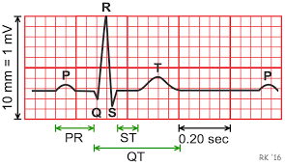
Normally, the electric impulses cross the heart, which contracts approximately 60 – 80 times per minute at rest. Each contraction of the ventricles represents one heartbeat.
The resting ECG is a simple, quick and painless test. The resting ECG can detect certain heart conditions such as hypertrophy of heart, ischemia, myocardial infarction, sequelae of myocardial infarction, cardiac arrhythmias, etc. The test takes about 5 minutes and no preparation is necessary.
During the ECG, you are lying on your back and several small electrodes are placed on your arms, legs and chest. Some aqueous gel is used allowing for adhesion to the skin. The recording takes a few seconds and then the electrodes are removed. No discomfort is felt and you can resume your normal activities immediately after the test.

thalach: The person’s maximum heart rate achieved :-
A normal resting heart rate for adults ranges from 60 to 100 beats per minute.
To check your pulse at your wrist, place two fingers between the bone and the tendon over your radial artery — which is located on the thumb side of your wrist. When you feel your pulse, count the number of beats in 15 seconds. Multiply this number by four to calculate your beats per minute.

Exang :-
Stable angina is usually triggered by physical activity. When you climb stairs, exercise or walk, your heart demands more blood, but narrowed arteries slow down blood flow.

ca: The number of major vessels (0–3) :-
colored by flourosopy

The major vessels that pouring blood in right atrium is - the inferior vena cava, the superior vena cava and pulmonary artery channels.

thal (thalassemia) :-
Thalassemia (thal-uh-SEE-me-uh) is an inherited blood disorder that causes your body to have less hemoglobin than normal.
Hemoglobin enables red blood cells to carry oxygen. Thalassemia can cause anemia, leaving you fatigued. If you have mild thalassemia, you might not need treatment.

